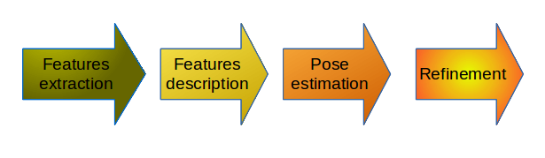
Edge
Segmentation
Pairwise
Geometric
Histogram
Probabilistic
Hough Transform
Template matching

